1. **Executive Summary**

**Problem Statement**

The project deals with the identification of lung cancer, which affects roughly about 225,000 people every year and accounts to about 12 billion in health care costs in the final stages. Therefore, early detection of cancer is critical to give the patients the best chance of recovery and survival.

The goal of this project is to evaluate the data (Slices of CT scans) provided with various pre-processing techniques and analyze the data using machine learning algorithms, in this case 3D Convolutional Neural Networks to train and validate the model, to create an accurate model which can be used to determine whether a person has cancer or not. This will greatly help in the identification and elimination of cancer cells in the early stages.

Therefore, an automated method capable of determining whether the patient will be diagnosed with lung cancer is the aim of this project.

**Dataset Information**

The dataset consists of thousands of CT images from high risk patients in DICOM format (detailed information given below). Each image contains a series with multiple axial slices of the chest cavity and a variable number of 2D slices, which can vary based on the machine taking the scan and the patient.

**DICOM Standard**

DICOM is an acronym for Digital Imaging and Communications in Medicine. Files in this format are saved with either a DCM or DCM30 file extension, but some may not have an extension at all. It is used for both communication protocol and a file format i.e., it can store medical information, such as ultrasound and MRI images along with the patient’s information, all in one file.

The format ensures that all the data stays together and provides the ability to transfer information between devices that support the DICOM format. To view the information in the files there are two methods, they are

**Opening DICOM files with Free viewer**

I have used the MicroDicom File viewer, which is a free to use software exclusively for viewing the DICOM files. The image along with the metadata can be found making it easy and efficient to access the data for research and development purposes.

**Using Libraries to extract the information**

The DICOM standard is complex and there are number of different tools to work with DICOM files, I have used the pydicom package, which is a package that can be imported towards working with images in python.

**File Description**

Each patient ID has an associated directory of DICOM files and is in the header of the file along with the patient name, the exact number of images per person varies with every file.

stage1.7z - contains all images for the first stage of the competition, including both the training and test set.

stage1_labels.csv - contains the cancer ground truth for the stage 1 training set images.

data_password.txt - contains the decryption key for the image files.

1. **Implementation Overview**

**Setup Process**

**Tools and Libraries**

* **Anaconda Navigator** – We used Anaconda Navigator to use **Jupyter notebook** for python programming.
* **NVidia CUDA –** Tool used to apply on the GPU for increased and better performance of the system, can only be used on machines having NVidia graphics.
* Installed **Tensorflow** GPU version on **Jupyter Notebook** to run the neural network.
* Installed **Pydicom** for reading the DICOM (Digital Imaging and Communications in Medicine) files.
* Installed **OpenCV** for manipulating the image like resizing the image.
* Installed **MatPlotLib** for visualization of the image files and various presentation purposes.
* Installed **pandas** (used for reading operations on csv files and computation of confusion matrix), **os** (File and directory manipulations), **scikit-learn** (to compute confusion matrix) etc.,

After the selection of the project, we had to decide with the technologies to work with and after excessive research and testing, we could zero out on the above technologies. Firstly, we had to install anaconda with python version 3.5 as it supports a variety of functions over the other versions, then we had to download and setup NVIDIA CUDA on the system, since the size of the processes were large, it was very time intensive procedure to perform with the existing CPU, hence we used CUDA to make use of the GPU for processing and analyzing purposes leading to efficient processing of the datasets. We had problems when we were setting up CUDA as multiple library files were to be places exactly in certain locations for it to work properly.

We had also faced a challenge to use Tensorflow as the backend while using CUDA for GPU support as we did not have much reference materials, therefore we had to tweak and plug features on a trial basis to identify the perfect combination for Tensorflow to work.

Finally, we could run tensorflow and use the libraries provided. Other libraries were installed and used to complete the project and the description of those libraries are mentioned above.

**Working Process**

The working structure is simple, it consists of three major steps, they are

* Data Pre-Processing
* Computation of data via Neural network using 3D-CNN
* Computation of confusion matrix and cancer prediction

If we need to analyze the working structure of the project, a few concepts about CNN need to understood and we had research through a lot of research papers leading to comprehensive understanding of the activities involved in processing, training and testing a neural network.

**Data Pre-Processing**

Let’s look at the data that we are going to work with, and to do so I have used a DICOM file reader to learn about the data. Below is a screenshot of the reader containing the Image and the metadata.

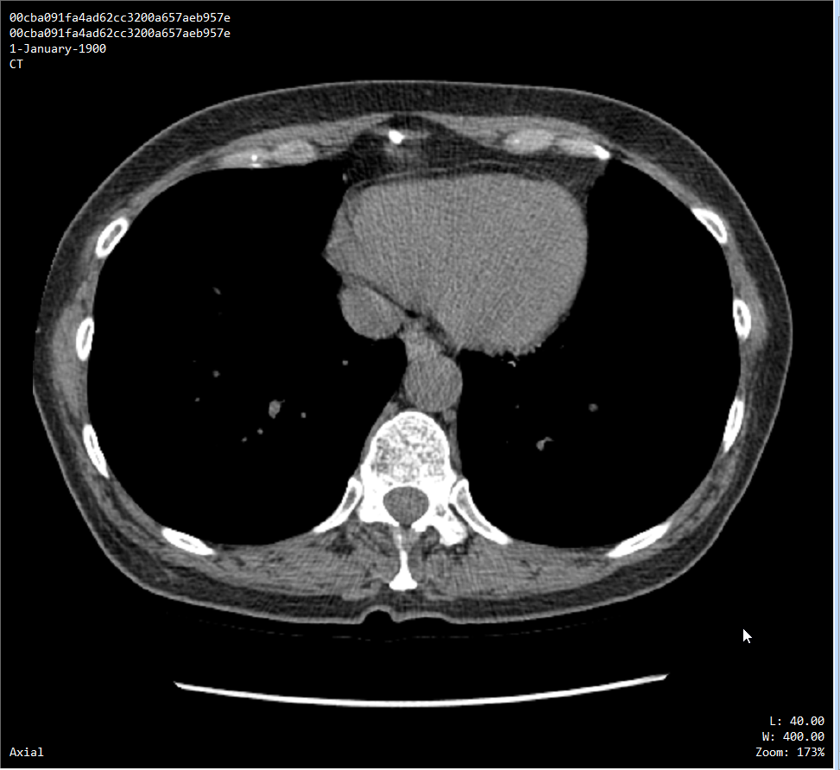

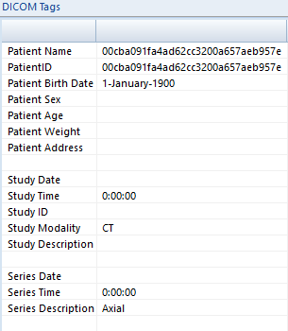

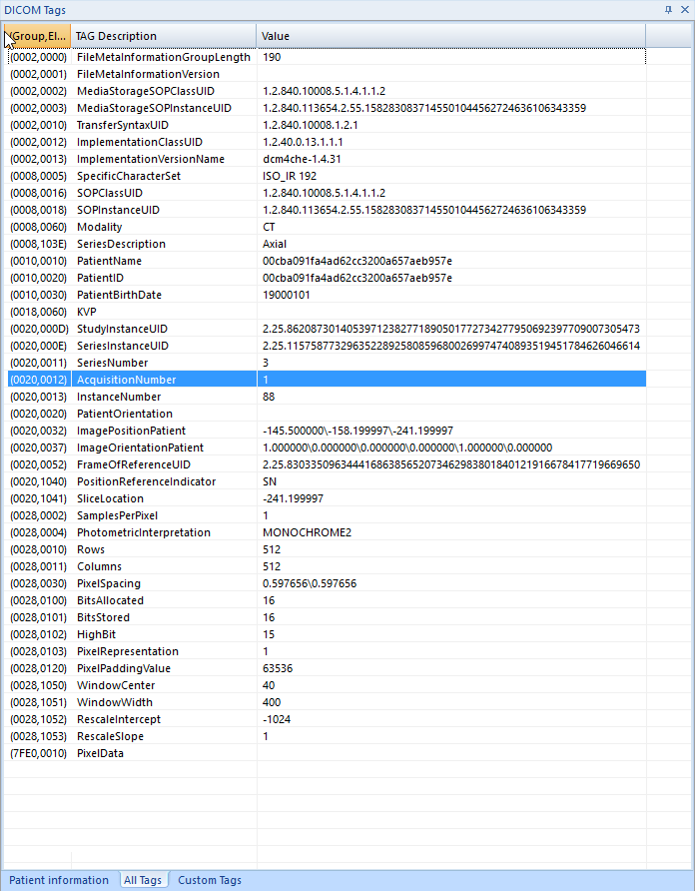

Therefore, with the above data we could understand what the dataset consisted and how we could use it to solve the problem statement. The patient ID and name is provided for every patient in every scan in the folder and ID acts as a unique identifier between the patients.

Taking more metadata tags into consideration we could find a few anomalies which are potential causes for pre-processing. Example: Irregularities in the size of the x and y axis of the image, Depth of the image dependent on the number of axial files available in the folder, sometimes it was the same and sometimes not.

The location of the one single scan of the entire 3D lung scan was also given for better understanding about which segment of the scan we were dealing with.

This section deals with image pre-processing in specific, as tedious procedures were undertaken to merge these individual slices into 3D images so that we can feed them into a 3D Convolutional neural network. Since we are dealing with large dataset (160GB) it is time intensive and slow in computation

Using the libraries pydicom, matplotlib and OpenCV, we can read, visualize and resize the images to the specified format suitable based on the computational speeds and capacity of the system.

**3D CNN Computation**

This section consists of the steps involved taking the processed data and using it to determine the accuracy of the model, to predict whether a person could be affected with cancer or not. To understand the composition of what goes into creating a Convolutional neural network and the layers that are used to process the data, a summary of every layer and its functions that we have used in the project is provided, the summary is an amalgamation of inferences that we have achieved based on various research papers whose links are also provided (references).

We should input the 3D image that we have created in the pre-processing section and set the various layers with values, there is no hard and fast rule that values are fixed, hence we had to test the layers’ multiple times with different values and arrive at a set of values that were optimal.

So, when we train the model, we send in a part of the data (majority) and keep the rest of it for validation purposes to check is the model is well trained. We had 1595 images in total, and we provided 1495 images as input for training the model and 100 images for validation.

The idea here is to complete training the model with 1495 images and then pass the 100 validation images to test the model to provide an accuracy as to how well the model is trained and can predict accurately. In short, we are providing the test data on the trained data model to identify the accuracy (final accuracy).

We also had setup the number of epochs to run, batch size of the input data specifying how many images are to processed at once, input size of the image was also specified as 50x50x20, it is very small compared to the original size of the image, but our systems could accommodate only such capacity, this in turn caused a drop in the quality and quantity of the dataset.

This drop in metrics lead us to observe that we are not using enough information for the model to train on and hence affect the accuracy of the model. After running the model for 100 epochs, we found that the percentage of accuracy was stagnant at the 83rd epoch at around 72%, which is the maximum accuracy we could achieve, we could not achieve more due to lack of more data causing the model to overfit, leading to lower accuracy. Before identifying the final accuracy, we had to mix and match the layers in between to get the optimal layer composition, i.e., At first we had set 3 layers and we had achieved an accuracy of 54% with just 3 epochs run, then we increased the number of epochs and observed that the accuracy increased, we kept increasing the layers and finally reached 6 layers which was optimal and 100 epochs was just fine to get the maximum accuracy.

**Computation of confusion matrix and cancer prediction**

The confusion matrix is a way to determine whether the model is good or not. Here we have done the confusion matrix for predicted labels vs actual labels. The 0’s represent no cancer and the 1’s represent cancer. Ideally the false positives and the false negatives value should be low.

1. **Errors faced during execution**

I have specified most of the outcomes from the implementation overview, but when it comes to the CNN process, there were many challenges faced

**Resizing the z axis due to irregularities in dimensions.**

We noted that for each patient the number of slices varied. Feeding patient with various slices (z axis) to the neural network would pose a problem and would not give us the desired results. So, we must chunk the slices and make them smaller and equal.

**Tensor reshape error**Tensor automatically throws a reshape error every time the data is fed to the neural network and this would pose as a problem.We passed this so that tensor can take the shape specified by us.

**Resource exhausted error**

Tensorflow was using the GPU at the back and every time the neural network ran, so the kernel had to be restarted to free up the GPU’s memory. When trying to feed a larger image size, we ran into the same error. This was because there was no sufficient memory to process such a huge dataset.

**Dataset is not enough – overfitting occurs**

The total dataset size is 1595 out of which 1107 patients do not have cancer, 390 patients have cancer and 98 patients do not have labels. The dataset for number of patients having cancer is very low. This is the reason why overfitting occurs and cancer predictions are not that accurate. One way to overcome this problem is by adding more cancer patient datasets which is currently not available.

1. **Code Snippets:**

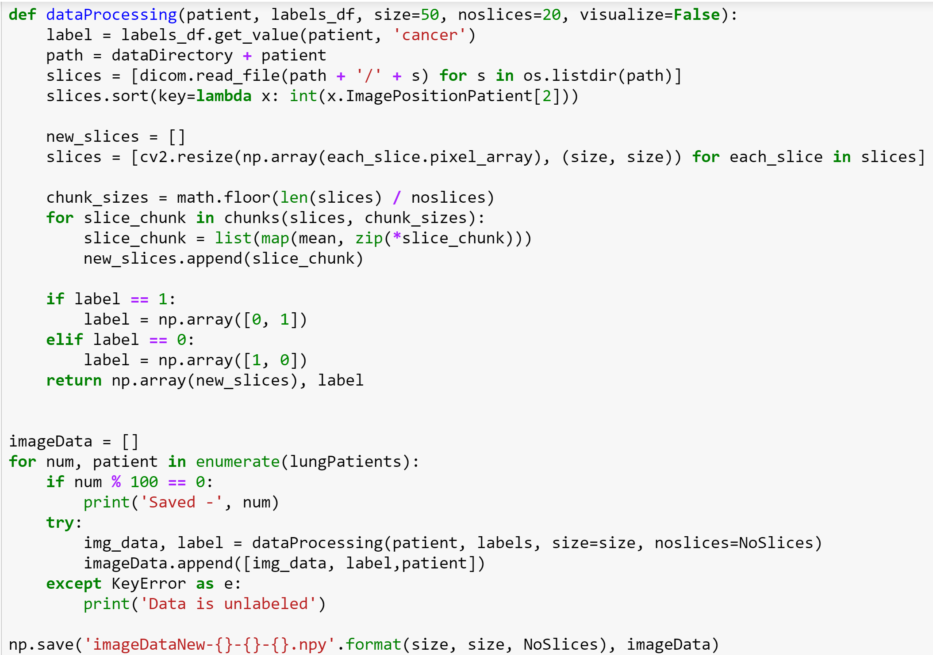

This part preprocesses the data to a lower size along the x,y,z axis. This pixel data along with the patient id and patient label is saved to a numpy file.

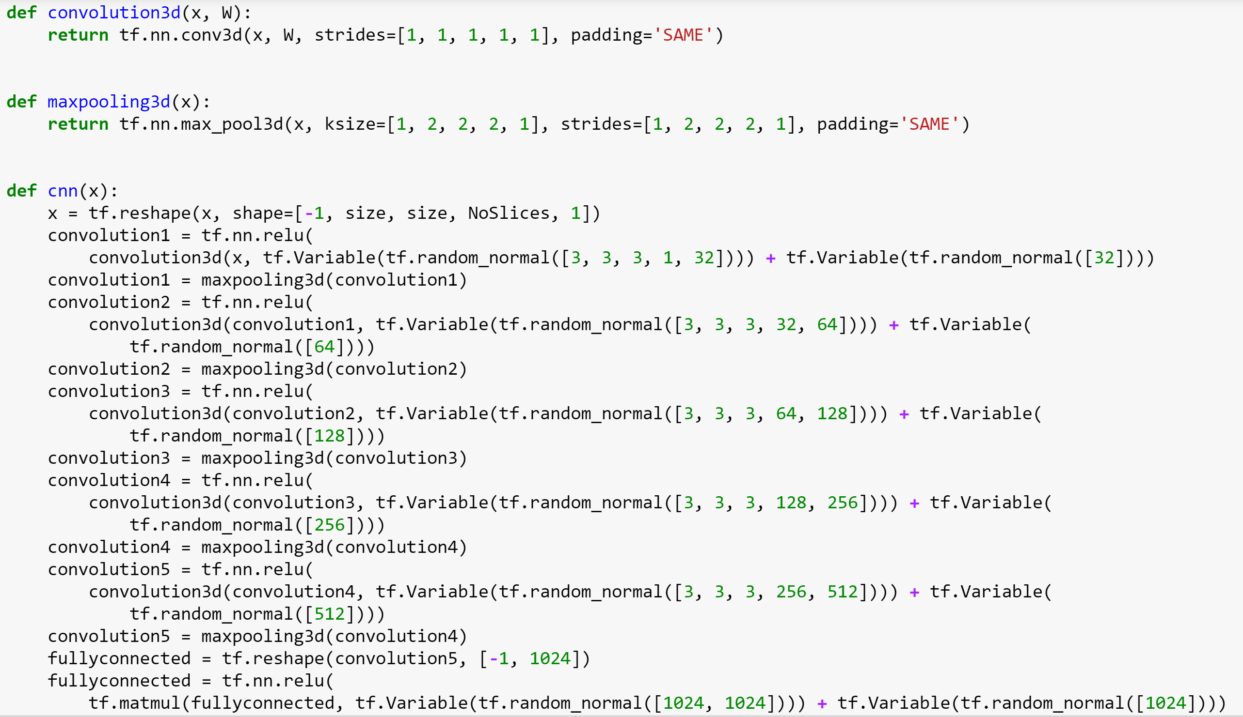

This is the code for our 5 layer 3D Convolutional Neural Network.

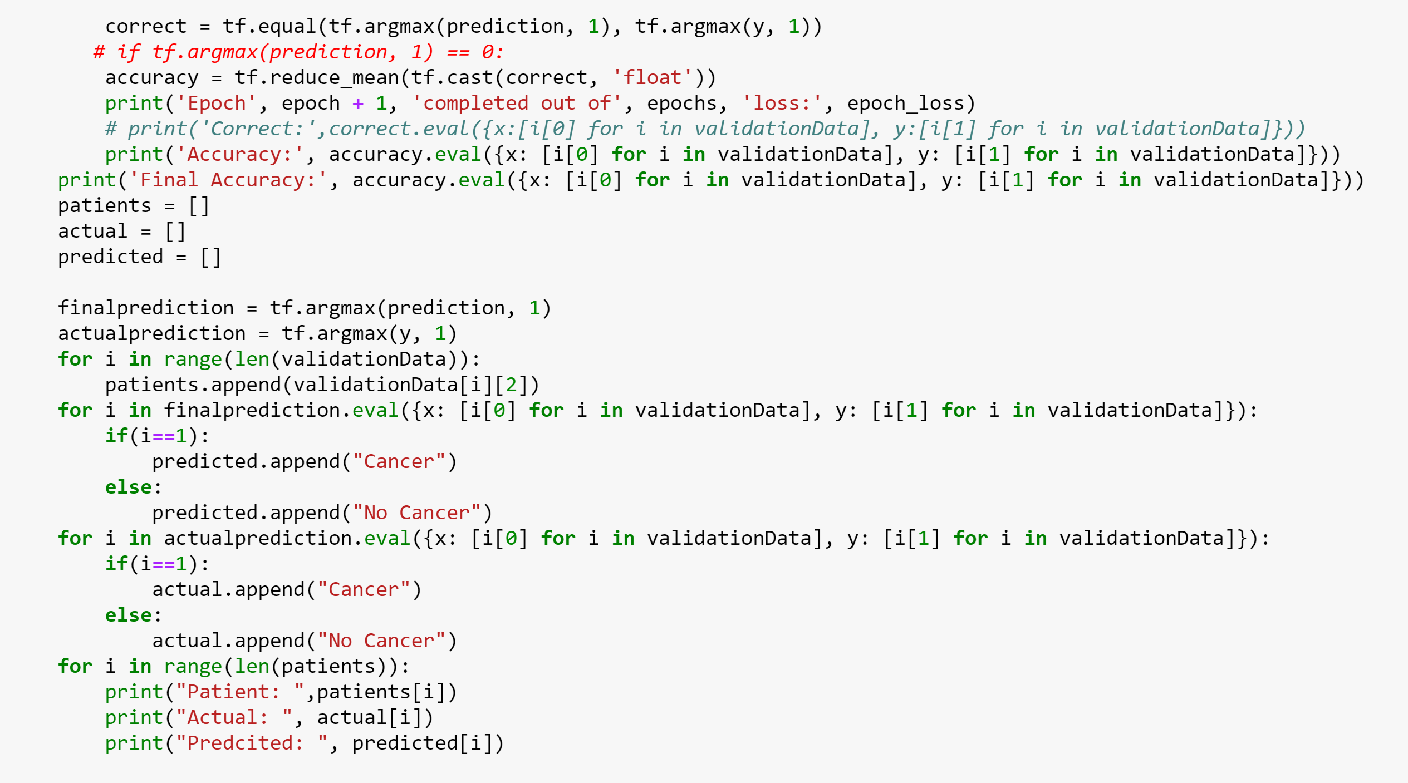

Here we are calculating the accuracy and reducing the loss by using an adam optimizer. And we are displaying the labels of patients in the test data and their actual and predicted labels. A confusion matrix is also done to show the effectiveness of the model.

1. **Conclusion**

From the above observations, we can draw a suitable conclusion, there where multiple challenges when executing and setting up the environment in which a few technologies that we have used do not even have feasible documentation for implementation, apart from overcoming all those hurdles, we could take away immense knowledge ranging from setting up of the environment to development section and analysis using various machine learning techniques. Thus, I conclude that the Lung Cancer Detection System using Convolutional Neural Network is completed and documented successfully.

1. **Future Scope**

The idea that we have presented is at the very beginning of its deployment phase and thus we wish to extend our project by implementing a model that can make valuable predictions based on the reports specified in the datasets and achieve a higher value of accuracy by using Microsoft ResNet approach to build a network, to provide much higher learning rate of the nodes increasing the performance of the model and minimizing the losses effectively. Once when we can synthesize the above features we can move forward with the deployment process making this application ground breaking regarding the medical industry, improving the health care system thus causing a huge beneficial impact on the lives of many individuals.

**Screenshots**

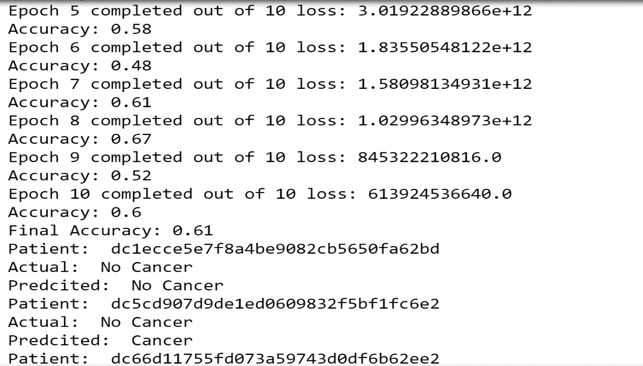

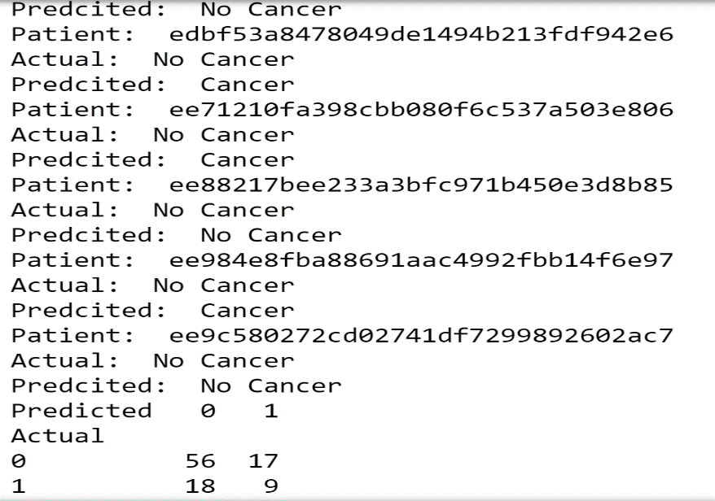

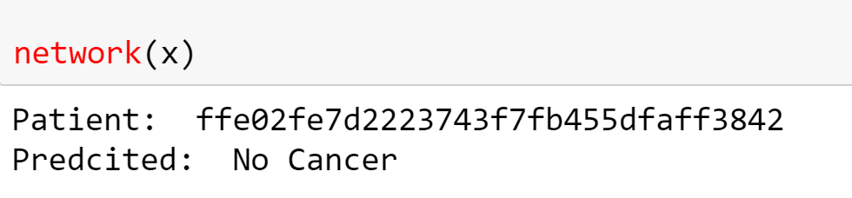

Confusion matrix represented in graphical format, the darkest square specifies the most populated / dense region.

y-axis – actual values

x-axis – predicted values

